## ****VISUALIZATION TOOL FOR ELECTRI VEHICLE CHARGE AND RANGE ANALYSIS****

## ****INTRODUCTION****

## ****OVERVIEW****

## ****Electric Vehicle****

An [electric vehicle](https://intellipaat.com/blog/what-is-electric-vehicle/) is either partially or entirely powered by electricity. Electric cars have fewer moving components and are simple to maintain. They are also incredibly ecologically beneficial because they do not utilize any fossil fuels such as petrol, diesel, or even gasoline.

Electric cars utilize a rechargeable battery pack to power the electric motor rather than a combustion engine. The rechargeable batteries installed within the automobile must be recharged regularly.

**PURPOSE**

Electric vehicles are the key technology to decarbonise road transport, a sector that accounts for 16% of global emissions. Recent years have seen exponential growth in the sale of electric vehicles together with improved range, wider model availability and increased performance. Passenger electric cars are surging in popularity - we estimaate that 13% of new car sold in 2022 will be electric; if the growth experienced in the past two years is sustained, CO2 emissions from cars can be put on a path in line with the Net Zero Emissions by 2050 Scenario. However, electric vehicles are not yet a global phenomenon. Sales in developing and emerging countries have been slow due to higher purchase costs and a lack of charging infrastructure availability.

**PROBLEM DEFINITION &DESIGN THINKING**

**EMPATHY MAP**

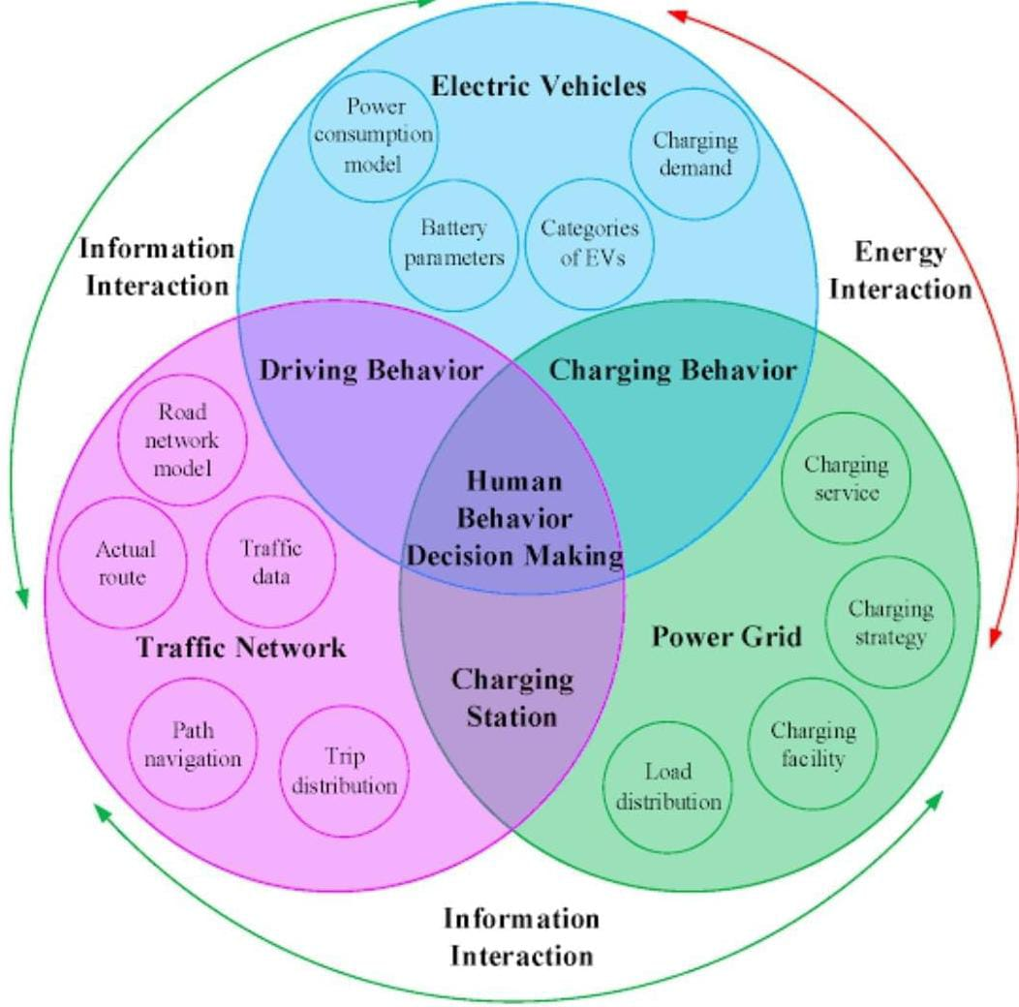

**BRAIN STORMING**

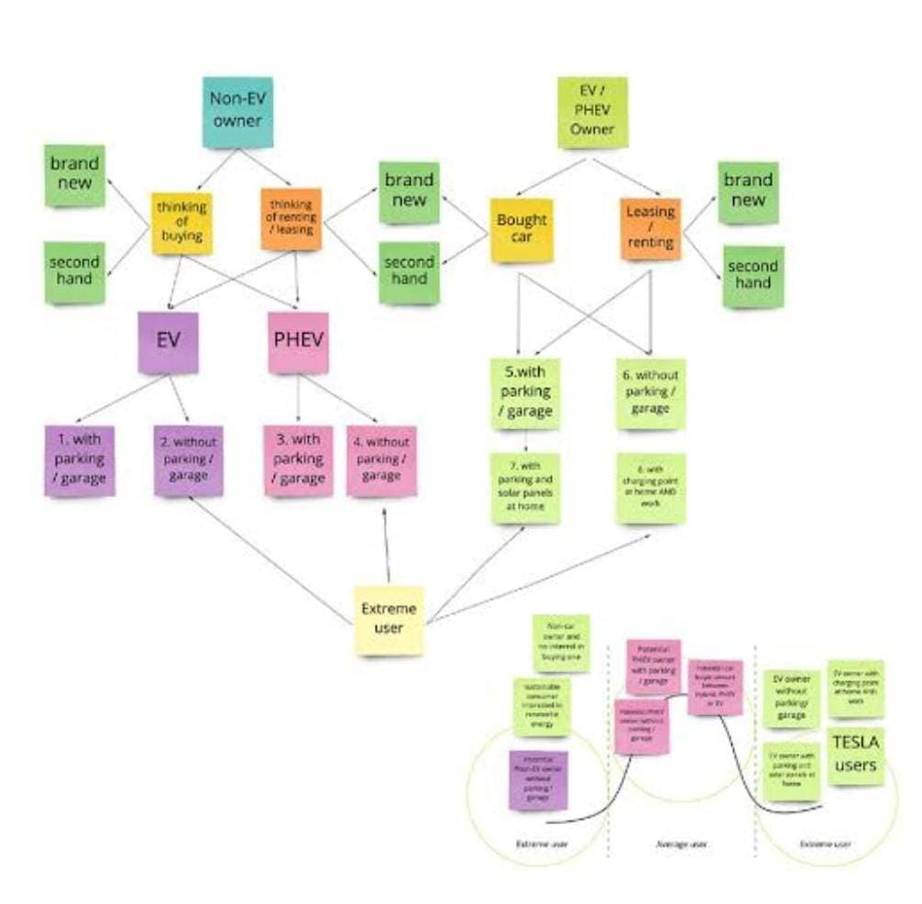

**RESULT**

Thenew EV’s are combined Electrical storage and propulsion systems with electronic sensors, controls, and actuators, integrated closely with software, secure data transfer to form a comprehensive transportation solution.

**Advantages of Electric Vehicles**

**Eco-friendly:**Because electric vehicles do not utilize fuel for combustion, there are no emissions or gas exhaust. Vehicles that run on fossil fuels contribute significantly to hazardous gas accumulation in the environment, thus driving an electric car can help contribute to a cleaner environment.

**Renewable energy source:** Electric vehicles run on renewable power, whereas conventional automobiles function on the combustion of fossil fuels, which reduces the world’s fossil-fuel stocks.

**Less noise and smoother motion:** Driving an electric car is significantly smoother. Because they lack fast-moving elements, they are quieter and produce less noise.

**Cost-effective:** Electricity is far less expensive than fuels such as gasoline and diesel, which are subject to regular price increases. When solar electricity is utilized at home, battery recharging is cost-effective.

**Low maintenance:** Because electric cars have fewer moving components, wear and tear is reduced when compared to traditional auto parts. Repairs are also simpler and less expensive than combustion engines.

**Government support:** Governments throughout the world have granted tax breaks to encourage people to drive electric vehicles as part of a green program.

## ****Disadvantages of Electric Vehicles****

**High initial cost:**Electric vehicles continue to be quite expensive, and many buyers believe they are not as inexpensive as traditional automobiles.

**Charging station limitations:** People who need to travel long distances are concerned about finding adequate charging stations in the middle of their journey, which are not always accessible.

**Recharging takes time:** Unlike conventional automobiles, which require only a few minutes to replenish their gas tanks, charging an electric vehicle takes many hours.

**Limited options:**Currently, there aren’t many electric car models to pick from in terms of appearance, style, or customized variations.

**Less driving range:**When compared to conventional automobiles, electric vehicles have a shorter driving range. Electric cars can be convenient for short-distance travel but are inconvenient for long-distance travel.

**APPLICATIONS**

**Lower running costs**

**Low maintenance cost**

**Zero Tailpipe Emissions**

**Tax and financial benefits**

## ****Conclusion****

Although electric vehicle manufacturers must solve the hurdles that are currently preventing people from purchasing, the future is clear: EVs will outlast gas-powered automobiles in the long run. Both GM and Nissan declared in January 2021 that they will go all-electric by the 2030s. Other automakers will undoubtedly follow suit.

**FUTURE SCOPE**

The Government wants India to be a 100%, electric vehicle nation by the year 2030. Under the new plan of the government, every car which will get sold in India from 2030 will be electric.

The availability of fossil fuels is limited, and their use is destroying our planet. Toxic emissions from petrol and diesel vehicles lead to long-term, adverse effects on public health. The emissions impact of electric vehicles is much lower than petrol or diesel vehicles.

electric vehicles (EVs) market is expected to be worth around at least ₹475 billion by 2025. The penetration of electric two-wheelers is projected to reach up to 15% by 2025 from 1% currently.

**APPENDIX**

[www.researchgate.net](http://www.researchgate.net)

[www.niti.gov.in](http://www.niti.gov.in)

[www.hindawi.com](http://www.hindawi.com)